Team
- Dr. Sabine Kapasi
Co-Founder
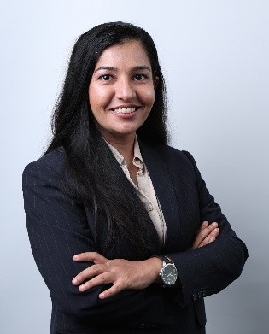
- Rhythm Nadda Gulati
Co – founder

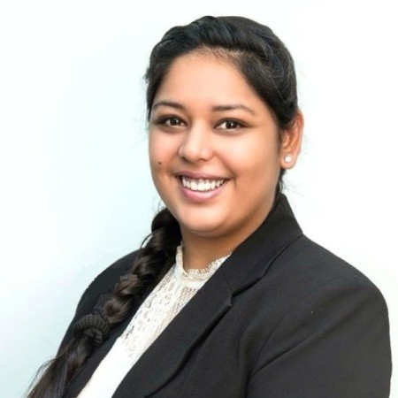

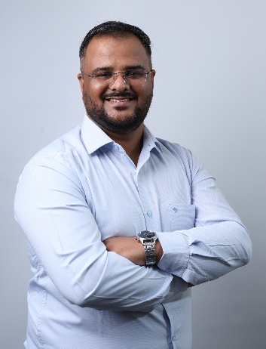
- Dr. Hardik Sankhla

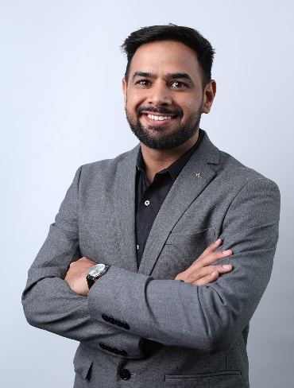
- Dr. Ashish Panghal

- Abhishek Padmanabhan
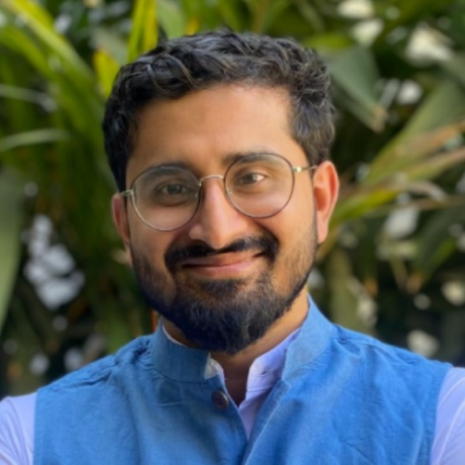

- Arun Patro
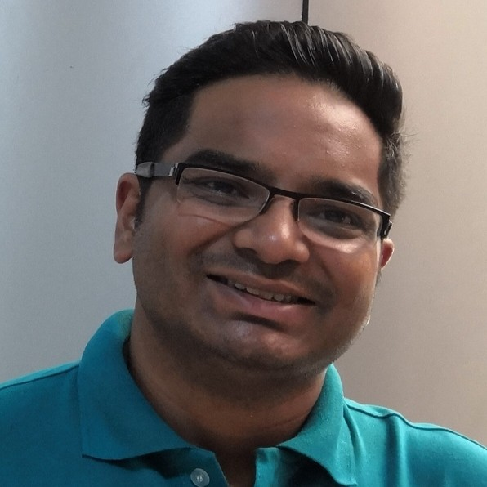

- Pooja Maurya
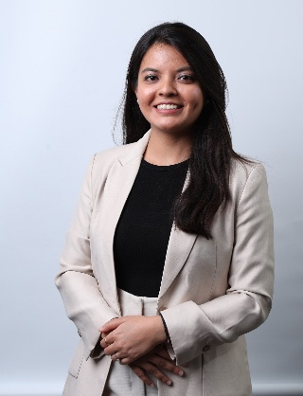

- Nipun Vaid Mehta
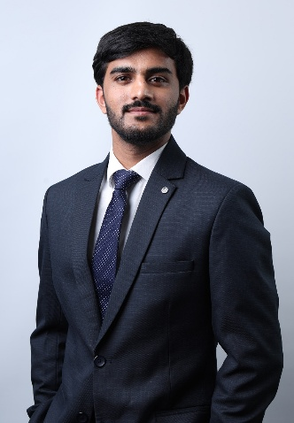

- Rachita Gupta
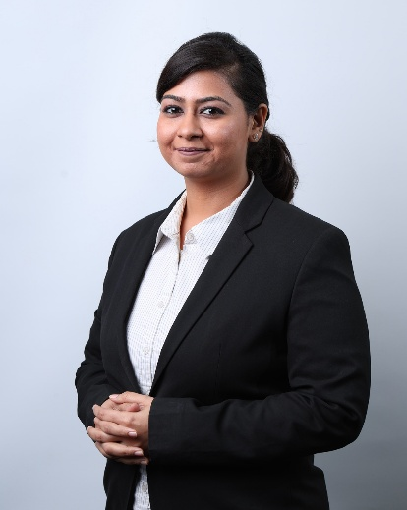

- Vedanshi Sharma
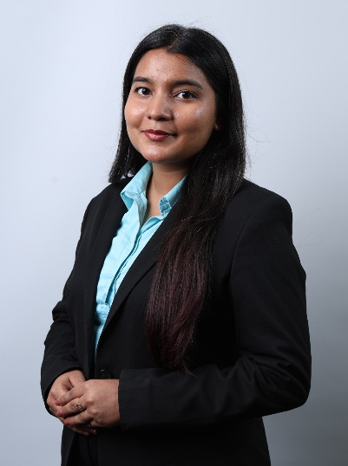

Advisors

- Dr. Rati Godrej
Godrej Industries Limited
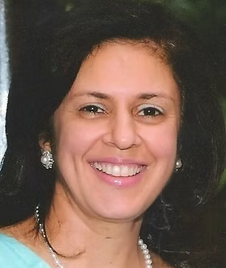

- Dr. Anand Deshpande - Chairman & MD, Persistent Systems
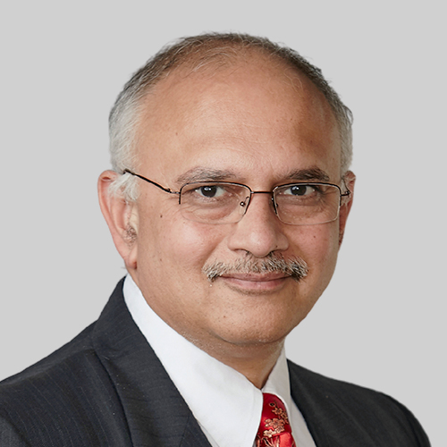

- Arjun Malhotra - HCL Co-Founder, Chairman magic Software
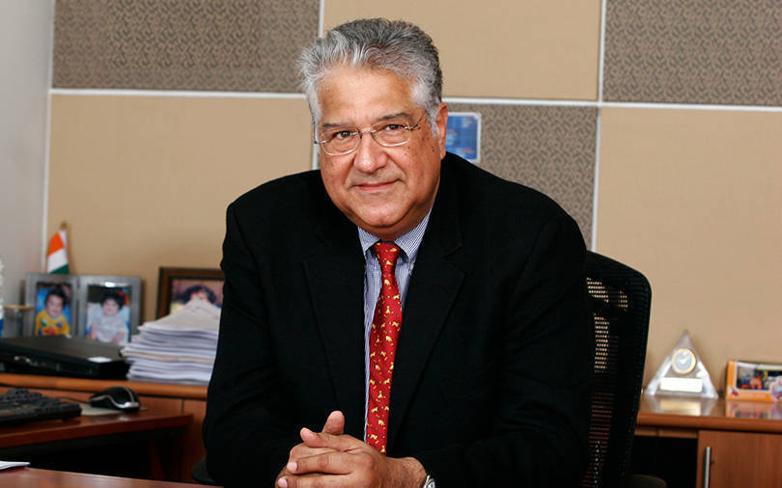

- Dr. Dhiraj Lal Kotadia - Chairman Emeritus, Sahajanand Medical Technologies
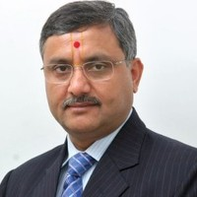
- Priya Agarwal Hebbar - Director, Vedanta Limited

- Mr. Prakash Bakshi - Former Chairman, NABARD
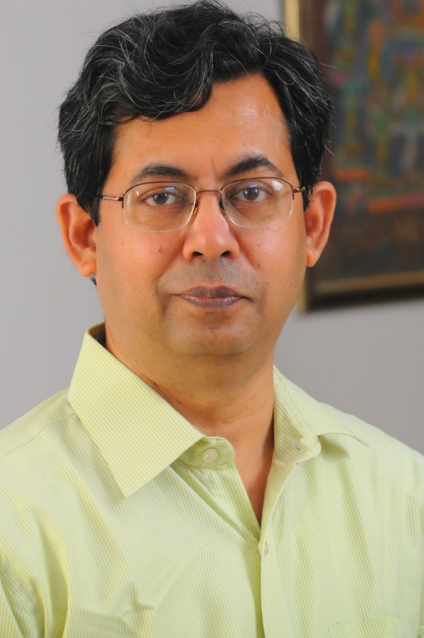

- Ashish Sehdev - Vice President & Market Leader, Everest Group

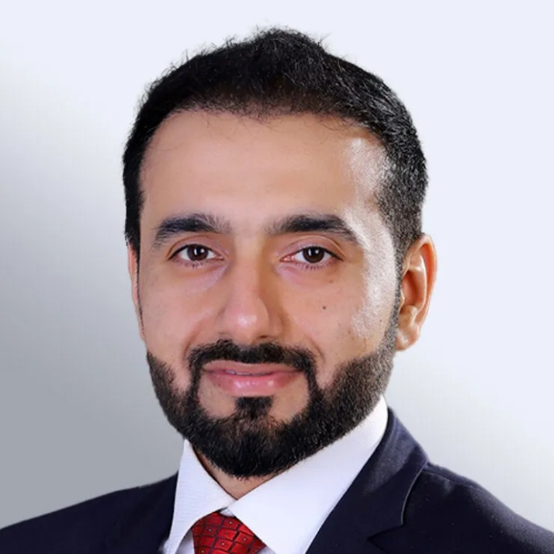
- Dr. Upasana Arora - MD, Yashoda Hospitals, National Chairperson, IACC
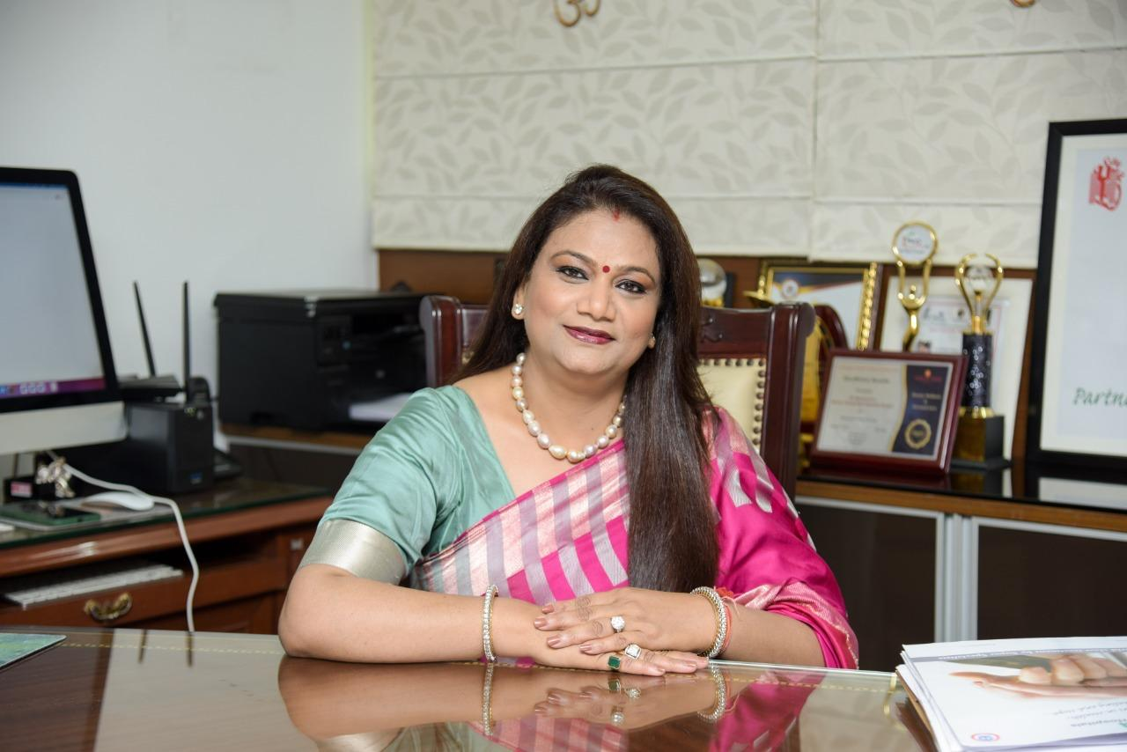

- Neiharika Rajiv - Co-Founder, GI Ventures
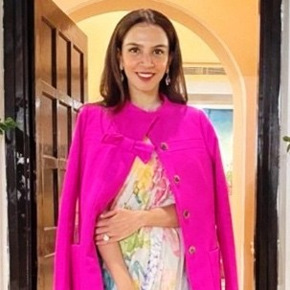

- Dr. Sonia Lal Gupta - Director, Metro Group of Hospitals
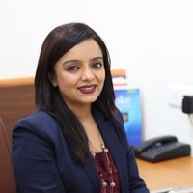

- Indu Navar - CEO & Founder, EverythingALS
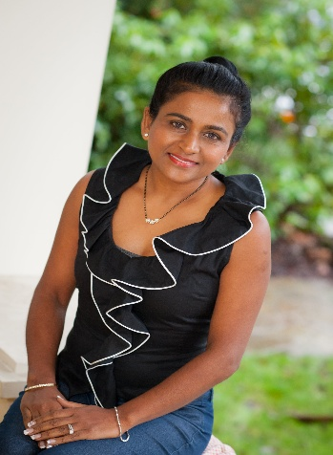

- Asha Jadeja Motwani - Founder , Motwani Jadeja Family Foundation
